Parametric Functions – Teaching Set 1
Covering topic 2-6: Creating your own parameterizations
Different sets of parametric equations that define the same curve are called different parameterizations of that curve.
The curve is the shape in the x-y plane which the point moves along, like y = x
A parameterization of a curve is the set of x(t) and y(t) which define some movement along the curve, like $x\left(t\right)=t^{2}$ and $y\left(t\right)=t^{2}$.

1). [C] How do different parameterizations produce different motions along the same path?
Same path, different parameterizations
$$x\left(t\right)=t$$  $$y\left(t\right)=t$$  $$0≤t≤100$$ | 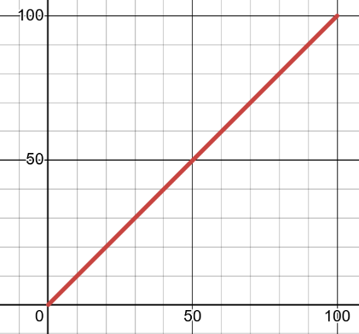    $$x\left(t\right)={\left(10-t\right)}^{2}$$  $$y\left(t\right)={\left(10-t\right)}^{2}$$  $$0≤t≤10$$  x  y  x  y
a). Where’s $t=0$ in each graph? How is the motion different? How do the different equations produce the different motions?

b). Say out loud: what, exactly, is a “parameterization” of a curve?

2). [C] Learning to control movement: compare three parameterizations of $y=x^{2}$
a | b | c
$x\left(t\right)=-t$  $$y\left(t\right)={\left(-t\right)}^{2}$$ | $x\left(t\right)=t+5$  $$y\left(t\right)={\left(t+5\right)}^{2}$$ | $x\left(t\right)=5-t$  $$y\left(t\right)={\left(5-t\right)}^{2}$$

a). First, how can you tell that all three sets of equations (parameterizations) are the curve $y=x^{2}$ just by looking at the x(t) and y(t) equations ?

b). A good way to start thinking about movement is to ask: where does the point start at $t=0?$ What direction does it move in when it starts (left? right?). Decide the answers for all three above.

c). Make a few of your own completely different parameterization for $y=x^{2}$. Try them out in desmos for $t≥0.$ See what different kinds of movement you can produce. Try and understand why your equations did that.

3). [P] Make parameterizations with specific movements

We’ll continue to use $y=x^{2}$ since it’s simple to work with. You want to be confident working with these ideas so you can choose whatever shape path you want, and write $x(t)$ and $y(t)$ equations that will start where you want, and move the way you want along the curve.

a). Make a parameterization of $y=x^{2}$ where the point starts at (6, 36) at t = 0 and moves right as time increases.

Hint: think about what x(t) needs to look like as a graph, table or equation. THEN find y(t).

b). Make a parameterization of $y=x^{2}$ where the point starts at (6, 36) at t = 0 and moves left as time increases.

c). Make a parameterization of $y=x^{2}$ where the point starts wherever you want along the curve, but reaches (0, 0) at t = 100.

(hint: find an x(t) that works, then deduce what y(t) has to be).

d). Verify that your solutions work in desmos

4). [C/P] Let’s create some parameterizations that will trace out the curve $y=x^{3}$
a. If $x\left(t\right)=2+t$ what does $y(t)$ need to be so it will trace out the path $y=x^{3}$ ? At t = 0, what are the points’ (x, y) coordinates? As t increases, what direction does the point move?

b. Create another parameterization for the path $y=x^{3}$ which would trace out the path more quickly than your answer for part a. (in other words, it would take less time to trace out the same path). Give both x(t) and y(t). Make sure you know WHY it works instead of just guessing and hoping!
c. Does $x\left(t\right)=t^{2}$, $y\left(t\right)=t^{6}$ trace out the path $y=x^{3}$ ? How do you know?
d. Create another parameterization that traces out $y=x^{3}$ but at $t=0$ your point should start at (2, 8) and move to the left along the curve as time increases. (Hint: again...find an x(t) that does what you want first)
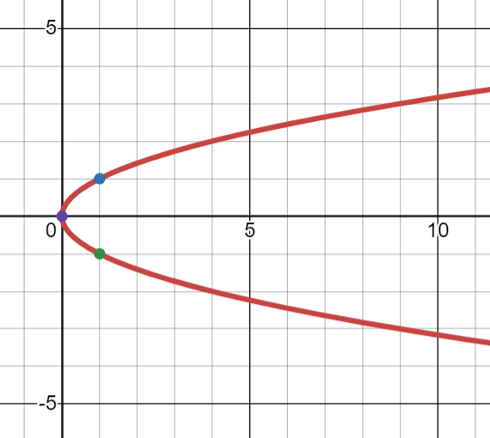
*5). [C/P] Can you think of a nice way of creating this sideways parabola path as a set of parametric equations? Do it!
Can you think of another approach that would make sense to get to the answer?
Remember: your goal is to learn ways of making sense of things flexibly for yourself. Once you have the answer you can always think if there’s a better or different way that might be useful in other problems.

SOLUTIONS
0). [C] How do different parameterizations produce different movements along the same path?

a. Where’s $t=0$ in each graph? How are the movements different?
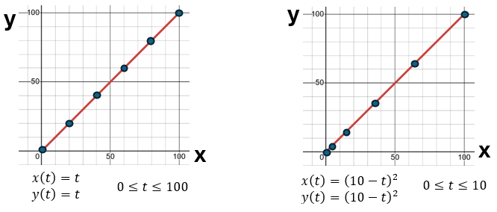
t = 100
t = 0
t = 80
t = 2
t = 60

t = 4
t = 40

t = 8
t = 6
t = 20
t = 10
t = 0

In the graph above, the movement is at a constant speed, starting at (0, 0) and moving right.  The dots are the positions every 20 seconds and you can see they’re evenly spaced. That means we move the same distance every 20 seconds. Constant speed! | In this graph, the movement starts at (100, 100) and moves left but is slowing down (decelerating) as the point gets closer to 0.  The dots are the positions every 2 seconds and you can see they’re not evenly spaced. As time increases, they’re spaced closer together, which means every 2 seconds the point travels a smaller distance. That’s slowing down!

b). Say out loud: what, exactly, is a “parameterization” of a curve? A parameterization of $y=x$ is a set of $x(t)$ and $y(t)$ equations that produce a movement along $y=x$. So: One parameterization would be $x\left(t\right)=t$ and $y\left(t\right)=t$. Another parameterization would be $x\left(t\right)=t^{2}$ and $y\left(t\right)=t^{2}$.

1). [C] Learning to control movement: compare three parameterizations of $y=x^{2}$
a | b | c
$x\left(t\right)=-t$  $$y\left(t\right)={\left(-t\right)}^{2}$$ | $x\left(t\right)=t+5$  $$y\left(t\right)={\left(t+5\right)}^{2}$$ | $x\left(t\right)=5-t$  $$y\left(t\right)={\left(5-t\right)}^{2}$$

a). First, how can you tell that all three sets of equations (parameterizations) are the curve $y=x^{2}$ just by looking at the x(t) and y(t) equations ?

In all three examples, the $y(t)$ equation has ${\left( something \right)}^{2}$ . What’s being squared is EXACTLY the equation for x. Imagine I asked you to find the y-coordinate at t = 3 for example b. You’d first do: $y\left(3\right)={\left(3+5\right)}^{2}=8^{2}$ . That first step of finding $3+5$ before you square it is what you’d do to plug into $x(t)$ to find the x-coordinate at t = 3. Then you’re squaring the x-coordinate to get the y-coordinate.
b). A good way to start thinking about movement is to ask: where does the point start at $t=0?$ What direction does it move in when it starts (left? right?). Decide the answers for all three above.

For A, $x\left(0\right)=0, y\left(0\right)=0$, so (0,0).
As time increases, x coordinates get smaller, so it’s going LEFT along the parabola.

For B, $x\left(0\right)=5$, $y\left(0\right)=25$ so (5, 25).
As time increases, x coordinates get larger, so it’s going RIGHT along the parabola.

For C, $c\left(0\right)=5$, $y\left(0\right)=25$ so (5, 25).
As time increases, x coordinates get smaller, so it’s going LEFT along the parabola.

c). Make a few of your own completely different parameterization for $y=x^{2}$. Try them out in desmos for $t≥0.$ See what different kinds of movement you can produce. Try and understand why your equations did that.

You can choose literally whatever you want for $x(t)$. Then just make sure $y\left(t\right)={\left(x\left(t\right)\right)}^{2}$. Some random examples:

$x\left(t\right)=2^{\sqrt{t}}-1$ and $y\left(t\right)={\left(2^{\sqrt{t}}-1\right)}^{2}$
$x\left(t\right)=\frac{3}{t+1}$ and $y\left(t\right)={\left(\frac{3}{t+1}\right)}^{2}$

The question is: can you create different movements on purpose?
A big realization here is that the motion is entirely controlled by your $x(t)$ equation. Your $x(t)$ equation determines the x location at different times. Your $y(t)$ equation just ensures your y-coordinate will the one you need to move along the specific path you chose.
A nice way to know what motions is going to happen is to think about the shapes of the graphs of basic families.
For example: Think about the shape of $y=5-5⋅2^{-x}$.
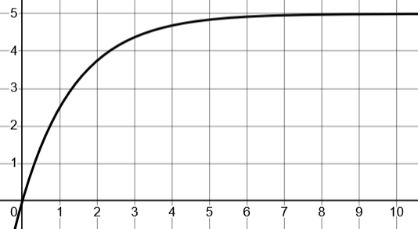
Now imagine using that to control your x-position:
$x\left(t\right)=5-{5⋅2}^{-t}$ (with $y\left(t\right)={\left(5-5⋅2^{-t}\right)}^{2}$ ).
What’s going to happen to the movement as $t$ goes from 0 to $∞$ ? Remember, we’ll be moving along $y=x^{2}$ but we’ll start at $(0,0)$ and move to the right, slowing down as we approach $(5, 25)$ but never getting there.
I designed the curve specifically to do that.
Notice that by $t=7$ I’m very close to $(5, 25)$. Could you modify the curve so that our movement still starts at $\left(0, 0\right)$ and slows down as we approach $(5,25)$ but takes longer to get there? For example, it doesn’t really get close until $t=20$ ?
3). Make parameterizations with specific movements
a). Make a parameterization of $y=x^{2}$ where the point starts at (6, 36) at t = 0 and moves right as time increases.

At time 0 I want the x-coordinate to be 6. As time increases I want x-coordinates to increase (so the point moves right).

I imagine x(t) this way… or this way .

$x\left(t\right)=6+t$ or $x\left(t\right)=t^{2}+6$

I know that if I want the path $y=x^{2}$ then the $y(t)$ equation has to square the $x(t)$ equation. So two possible answers would be:
$x\left(t\right)=6+t$ and $y\left(t\right)={\left(6+t\right)}^{2}$ or $x\left(t\right)=t^{2}+6$ and $y\left(t\right)={\left(6+t^{2}\right)}^{2}$

b). Make a parameterization of $y=x^{2}$ where the point starts at (6, 36) at t = 0 and moves left as time increases.

I imagine an x(t) where x = 6 when t = 0, but this time as time increases, the x coordinates decrease. Like one of these:

This gives two possible solutions (there are also others possible):
$x\left(t\right)=6-\frac{1}{5}t$ and $y={\left(6-\frac{1}{5}t\right)}^{2}$
$x\left(t\right)=6-t^{2}$ and $y={\left(6-t^{2}\right)}^{2}$

c). Make a parameterization of $y=x^{2}$ where the point starts wherever you want along the curve, but reaches (0, 0) at t = 100.

Many possible choices here. I started by imagining an $x(t)$ that outputs 0 when t = 100. Here’s one:

That gives me the solution: $x\left(t\right)=100-t$ and $y\left(t\right)={\left(100-t\right)}^{2}$

4). [C/P] Let’s create some parameterizations that will trace out the curve $y=x^{3}$
a. If $x\left(t\right)=2+t$ what does $y(t)$ need to be so it will trace out the path $y=x^{3}$ ? At t = 0, what are the points’ (x, y) coordinates? As t increases, what direction does the point move?

We need to take the equation that makes x and cube it since, literally $y={\left(x-coordinate\right)}^{3}$
So: $y\left(t\right)={\left(x\left(t\right)\right)}^{3}={\left(2+t\right)}^{3}$.

Now you can plug $t=0$ into your two equation to find the point is at $\left(2,8\right)$. Since $x\left(t\right)=2+t$ is an increasing function, that means as t goes up, x-coordinates are increasing. That means the point moves RIGHT as time increases.

b. Create another parameterization for the path $y=x^{3}$ which would trace out the path more quickly than your answer for part a. (in other words, it would take less time to trace out the same path). Give both x(t) and y(t). Make sure you know WHY it works instead of just guessing and hoping!
When $x\left(t\right)=2+t$ each second the x coordinate increases by 1. Let’s make it increase by more every second. Then the point will move faster.
Consider: $x\left(t\right)=2+10t$ and $y\left(t\right)={\left(2+10t\right)}^{3}$ . Imagine finding $x(1)$ and $x(2)$ and $x(3)$. Each time t increases by 1, the x coordinate increases by 10. (think about the slope of $x\left(t\right)=2+10t$). Therefore it’s going faster, but still at a constant speed.
If we want to accelerate, the x coordinate could grow faster than a constant:
$x\left(t\right)=t^{2}$ and $y\left(t\right)=t^{6}$

c. Does $x\left(t\right)=t^{2}$, $y\left(t\right)=t^{6}$ trace out the path $y=x^{3}$ ? How do you know?
We can see that $y={\left(t^{2}\right)}^{3}$ and we know $t^{2}$ is x. So $y=x^{3}$

d. Create another parameterization that traces out $y=x^{3}$ but at $t=0$ your point should start at (2, 8) and move to the left along the curve as time increases. (Hint: again...find an x(t) that does what you want first)
I’ll just think about x(t). $x(t)=2-t$ . Now I can find $y\left(t\right)={\left(2-t\right)}^{3}$.
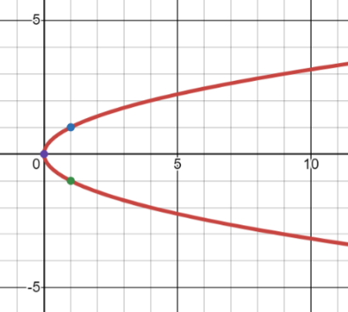
5). Can you think of a nice way of creating this sideways parabola path as a set of parametric equations?
Here’s one idea. This is like a parabola if you swapped x and y coordinates. So we could take a parameterization for a parabola, like $x\left(t\right)=t$ and $y\left(t\right)=t^{2}$ but just swap the role of x and y to get:
$x\left(t\right)=t^{2}$ and $y\left(t\right)=t$ .

Does that work? Two things you could do to check. One is plug in some different times and see what coordinates they point to.
Another would be to make a cartesian equation.
$$y=\sqrt{x}$$
If $x\left(t\right)=t^{2}$ and $y\left(t\right)=t$ . I can substitute y for t in the $x(t)$ equation to get: $x=y^{2}$. If you wanted it in $y=…something…$ form take the square root of both sides to get $y=±\sqrt{x}$ . And that’s exactly what the sideways parabola is:
$$y=-\sqrt{x}$$


A different approach is to start by looking at specific coordinates on the curve.
$$(9, 3)$$
$$(9, -3)$$
$$(4, 2)$$
$$(1, 1)$$
$$(1, -1)$$
$$(4, -2)$$
You might notice that the x-coordinate is always the y-coordinate squared. In other words: $x=y^{2}$.
This suggests that if we found a $y(t)$ equation, then
$$x\left(t\right)={\left(y\left(t\right)\right)}^{2}$$
So let’s make a $y(t)$ equation that does something we want.
Let’s say the y-coordinate starts at 5 and moves down: $y\left(t\right)=5-t$.
Since the x-coordinate is the y-coordinate squared, that gives me: $x\left(t\right)={\left(5-t\right)}^{2}$
So: $x\left(t\right)={\left(5-t\right)}^{2}$ and $y\left(t\right)=5-t$ would be a different parameterization for this same curve.

What should you take away from this problem? The process of what you can do to get yourself started. It always starts by noticing something and trying to connect it to math you know.
In the first approach, we noticed a connection to the parabola, but it was important to be able to think clearly enough to realize that you could swap the equations for $x(t)$ and $y(t)$.
The second approach relied on you deciding to label some easy to think about coordinates. Once you were looking at them, then you could notice the relationship between x coordinates and y coordinates. Then you’d need to know how to write that idea down algebraically.
These basic ways-of-making-sense will apply over and over to very different kinds of problems – not just things to do with parametric! These ways-of-making-sense are the core of what it means to understand math!

